ACTIVITY 5: BLOG PLATFORM API + UI
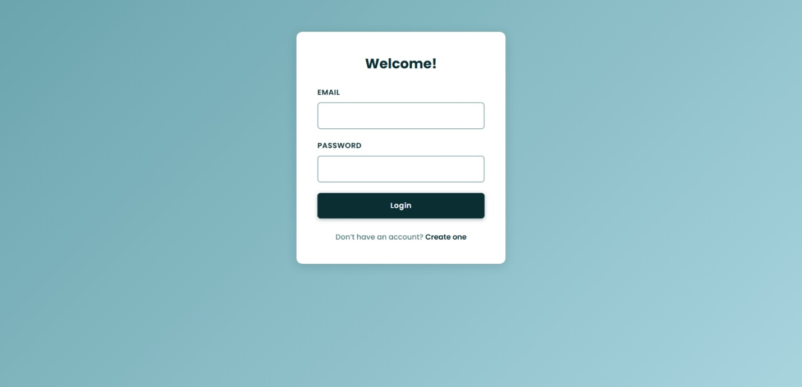
The Blog Platform displays posts in a visually organized card layout. Users can view detailed information for each post, including the title, content, author, and associated comments. The platform allows users to create new posts, edit or delete their own posts, and interact with existing posts by adding, updating, or deleting comments. Additionally, users can filter to view only their posts or view all posts for easier navigation and content management.
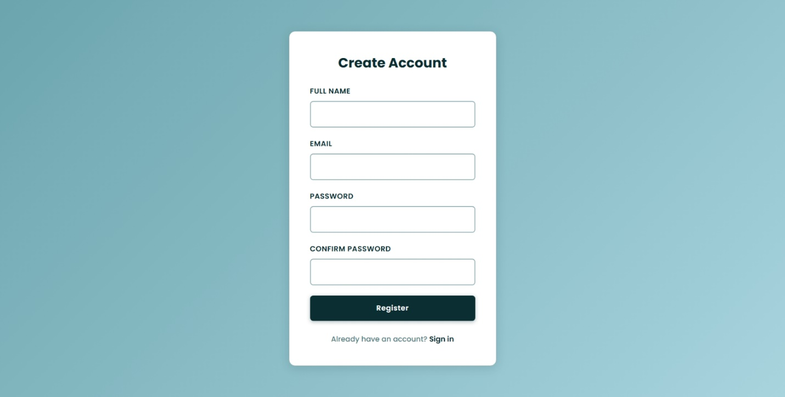
Login Page
Register Page
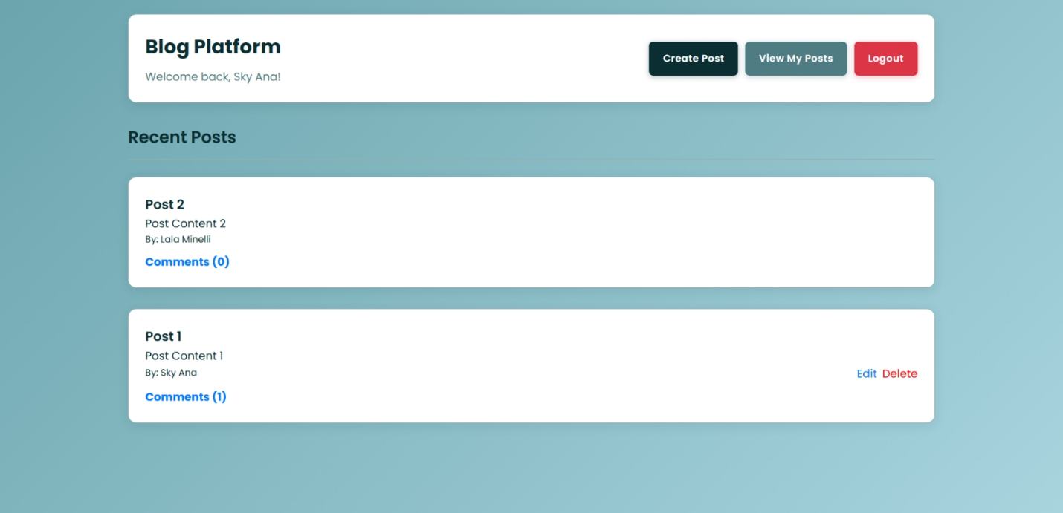
Dashboard Page (View All Posts)

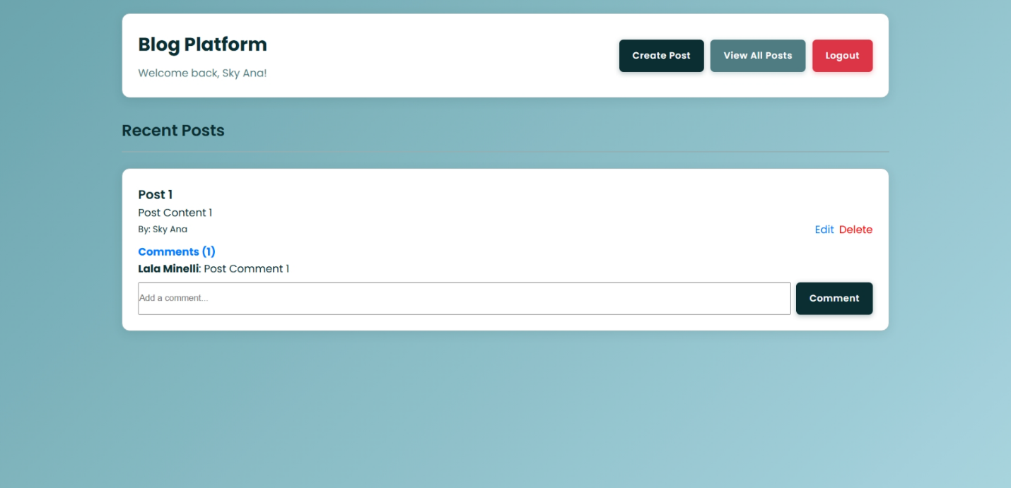
Dashboard Page (View My Posts)

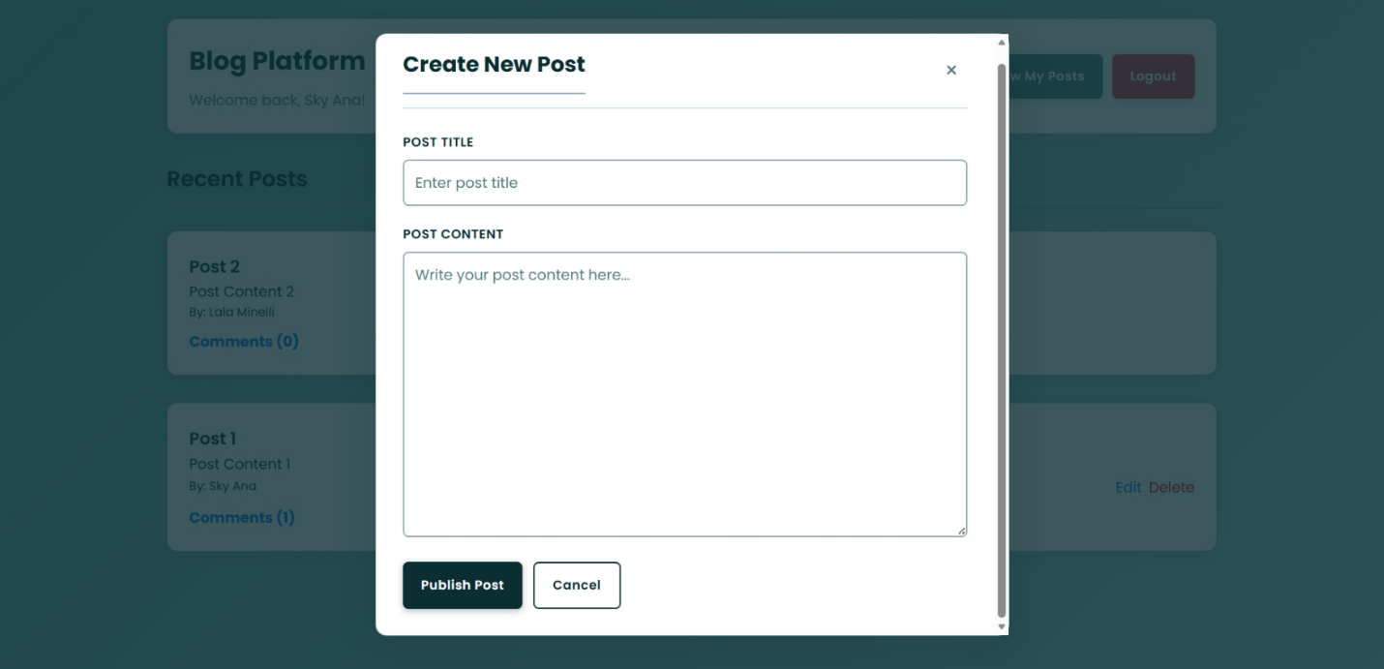
Create Post
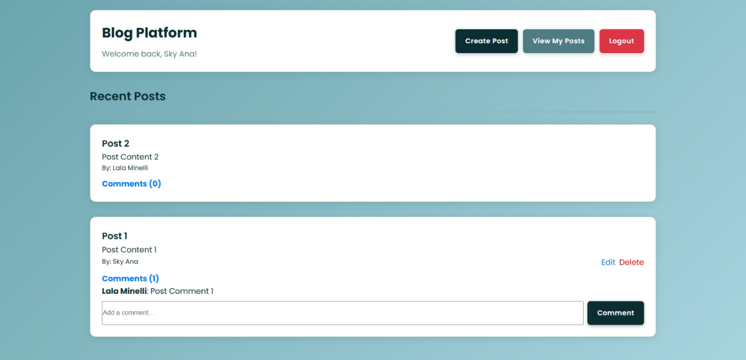
Comments

Instruction: How to Run the Project
• Open your VS Code terminal and navigate to the backend folder: “cd Activity5/backend”
• Install dependencies inside the backend folder: “npm install”
• Start the backend by typing this and keep it running in the background: “npm run start:dev”
• Open a new terminal and navigate to the frontend folder: “cd Activity5/frontend”
• Install dependencies inside the frontend folder: “npm install”
• To start the frontend type: “npm run dev”
• Open the provided link: http://localhost:5173
• Now you can use it as a blog platform.

